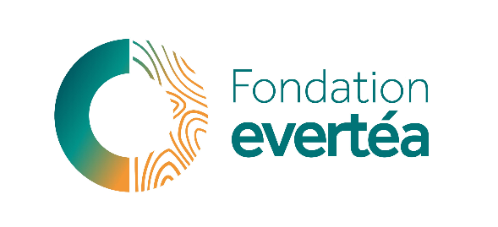

Research Program in Environmental Toxicology and Ecotoxicology

CALL FOR RESEARCH PROJECTS 2024
Solutions for better access to clean water in a changing climate

THE DOCUMENT MUST BE RETURNED
COMPLETED AND SIGNED, IN PDF FORMAT, NO LATER THAN JUNE 30TH 2024 AT 12 AM VIA EMAIL TO
contact@fondationevertea.org

FONDATION evertéa

3 rue Henry CHALAMET, 26000 Valence
TÉL : (+33) 9.70.65.03.50
contact@fondationevertea.org
SITE WEB : www.fondationevertea.org

SIRET : 798 715 033 00030 – CODE APE : 9499Z

Project title
Acronym
Project leader (name & lab)
Mail
Phone number
Duration
Amount requested
Abstract (300 words max)
Résumé non confidentiel en français (300 mots max)
Keywords

fondationevertea.org

Project context (1 page max)
Describe why your research is scientifically and socially relevant.

Objectives (1 page max)
Describe the main objectives of the project.

State of the art (1 page max)

Innovative aspects of the project, leverage effect and perspectives (1 page)
Describe how your project will open new pathways in your research domain, how you plan to leverage the grant from the evertéa Foundation, and how you plan to develop your research after the end of the grant.

Methodology and provisional schedule (1 page)
Describe the specific objectives of the project, as well as the methodology and the steps planned to reach them. All methodological choices have to be justified. In particular, the exposure concentrations must be justified, when applicable, as well as other exposure parameters, e.g. time of exposure, temperature, route of exposure, models used to evaluate exposure and effects. Similarly, if the project deals with climate change, the temperature/pH of exposure must be justified, e.g. according to an IPCC (Intergovernmental Panel on Climate Change) scenario.

Project leader curriculum vitae and consortium relevance (1 page)
Indicate your ORCID number, personal webpage, and all elements relevant with your proposal (5 most relevant publications, previous and present funding, students…). Write a short paragraph on the consortium relevance for the proposal.

References (not included in the page limits)

Budget breakdown

Categories | Rovaltain Foundation funding | Other funding (amount, funders) | Self-funding | Total
Staff cost (to be detailed in a specific paragraph)
Small equipment
Consumables
Reagents
Analysis kits
Subcontracting of analyses (< 30% of the total budget)
Travels (meetings and conferences)
Structure costs (< 4% of the total budget)
Communication
TOTAL

Budget justification (1 page max)
- Provide details on staff costs, including position, salary, time (in month, year) and type of employment contract (permanent, fixed-term).
- If the project is co-funded, provide details of (1) the nature and amount of co-financing and (2) what would happen if you do not receive the co-funding, i.e. will the project be still realized if the projected co-funding is not received.
- If the project completion depends on other parameters besides the evertéa Foundation funding, these constraints must be specified in the text and in the budget template.
- Provide any other information that may be useful to justify and understand the global budget of the project.

DATE:

Project leader SIGNATURE:

