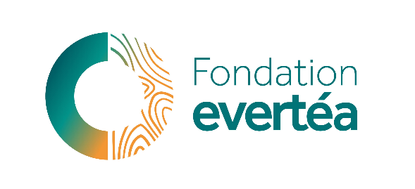


Research Program in Environmental Toxicology and Ecotoxicology

CALL FOR RESEARCH PROJECTS 2026
Artificial Intelligence in Ecotoxicology and Toxicology Research:
From Data-Driven Insights to Responsible Environmental Stewardship

THE DOCUMENT MUST BE RETURNED
COMPLETED AND SIGNED, IN PDF FORMAT, NO LATER THAN JULY 15TH 2026 AT NOON VIA EMAIL TO
contact@fondationevertea.org

FONDATION evertéa

3 rue Henry CHALAMET, 26000 Valence
TÉL : (+33) 9.70.65.03.50
contact@fondationevertea.org
SITE WEB : www.fondationevertea.org

SIRET : 798 715 033 00030 – CODE APE : 9499Z

Project title
Acronym of the project
Project leader (name & lab)
Mail
Phone number
Duration
Amount requested
Abstract
(300 words max)
Résumé non confidentiel en français (300 mots max)
Keywords (5)

fondationevertea.org

Project context (1 page)
Describe why your research is scientifically and socially relevant.

Objectives (1 page)
Describe the main objectives of the project.

State-of-the-art (1 page)
Give an overview of the most recent research conducted on the topic highlighting which data gaps your proposal will address.

Innovative aspects of the project, leverage effect and perspectives (1 page)
Describe how your project will open new pathways in your research domain, how you plan to leverage the grant from the evertéa Foundation, and how you plan to develop your research after the end of the grant.

Methodology and provisional schedule (1 page)
Describe the specific objectives of the project, as well as the methodology and the steps planned to reach them. All methodological choices must be justified. In particular, the exposure concentrations must be justified, when applicable, as well as other exposure parameters, e.g., time of exposure, temperature, route of exposure, models used to evaluate exposure and effects. Similarly, if the project deals with climate change, the temperature/pH of exposure must be justified, e.g., according to an IPCC (Intergovernmental Panel on Climate Change) scenario.

Project leader curriculum vitae and consortium relevance (1 page)
Indicate your ORCID number, personal webpage, and all elements relevant with your proposal (including the five most relevant publications, previous and present funding, students…) and include a short paragraph on the consortium relevance for the proposal.

References (not included in the page limit)

Budget breakdown

Categories | evertéa Foundation funding | Other funding (amount, funders) | Self-funding | Total
Staff cost (to be detailed in a specific paragraph)
Small equipment
Consumables
Reagents
Analysis kits
Subcontracting of analyses (< 30% of the total budget)
Travels (meetings and conferences)
Structure costs (< 4% of the total budget)
Communication
TOTAL

Budget justification (1 page)
- Provide details on staff costs, including position, salary, time (in months, years) and type of employment contract (permanent, fixed-term).
- If the project is co-funded, provide details of (1) the nature and amount of co-financing and (2) what would happen if you do not receive the co-funding, i.e. will the project be still realized if the projected co-funding is not received.
- If the project completion depends on other parameters besides the evertéa Foundation funding, these constraints must be specified in the text and in the budget template.
- Provide any other information that may be useful to justify and understand the global budget of the project.

DATE:

Project leader SIGNATURE:

